**SHIMONI DEMONSTRATION SCHOOL- KIRA**

**MID TERM TW0 EXAMINATIONS, 2023**

**MIDDLE CLASS, ENGLISH**

**Name ____________________________________________________**

1. Read and Match

 Mosque

 School

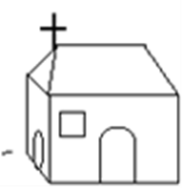 hospital

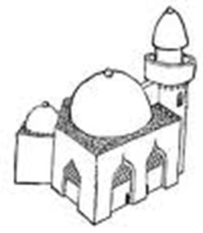 Church

1. Cross the different word.

teacher cook cook

Cleaner cleaner askari

doctor nurse doctor

1. Read and draw.

|  |  |  |  |
| --- | --- | --- | --- |
| Mat | Pot | Chair | broom |
|  |  |  |  |

1. Colour the pictures

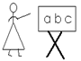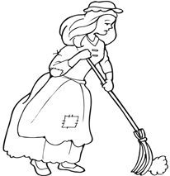

**END**